ADAPTABILITY

**Adaptability** in the context of AI refers to a system's ability to adjust and respond to changes in its environment. This concept is crucial for creating intelligent systems that can react appropriately to various situations.

HOW DOES MACHINE LEARNING WORK?

Machine Learning works by using algorithms to analyze large datasets and identify patterns, training the model through statistical methods. ML algorithms learn from data, adjusting parameters to maximize performance. Once trained, the model can make predictions or decisions on new, unseen data.

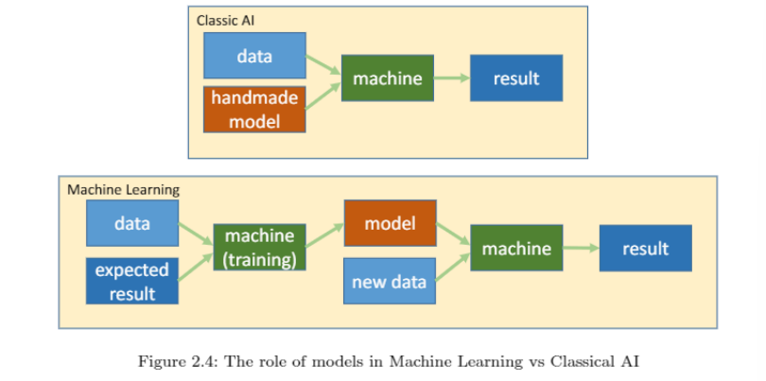

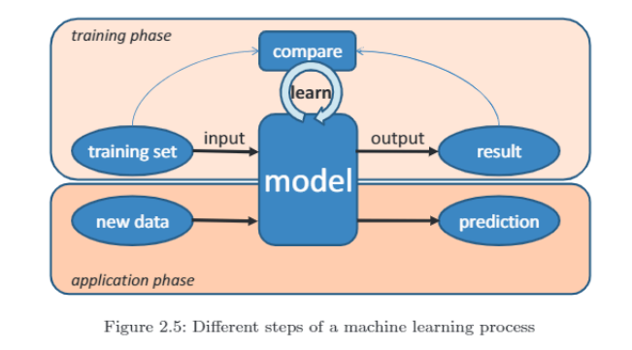

APPROACHES TO MACHINE LEARNING

1. **Supervised Learning**:

* Uses labeled data (input-output pairs) to train a model.
* Techniques: Classification (discrete outputs), Regression (continuous outputs), Probability estimation.
* Example: Spam email classification based on features like grammar, sender, etc.
* 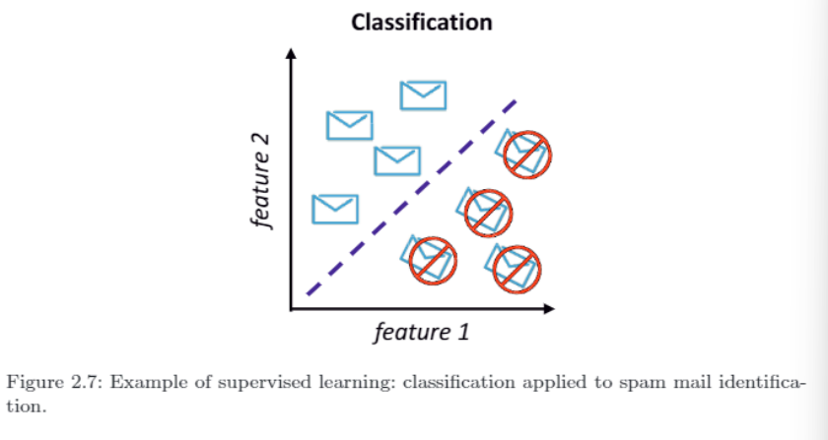

2. **Unsupervised Learning**:

* No labeled output data; identifies patterns in input data.
* Technique: Clustering (K-clustering) to group similar data points.
* Used for exploratory analysis and pattern discovery.
* 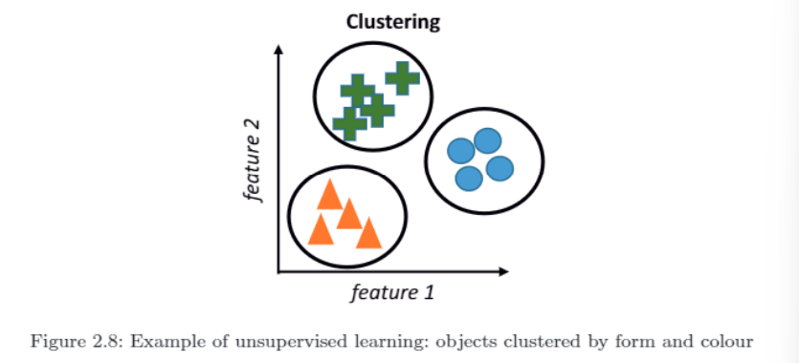

3. **Reinforcement Learning**:

* Learns by interacting with the environment, receiving rewards or penalties for actions.
* Example: A robot learning to navigate a room by receiving rewards for moving closer to a target.
* Focuses on learning policies that maximize rewards.
* 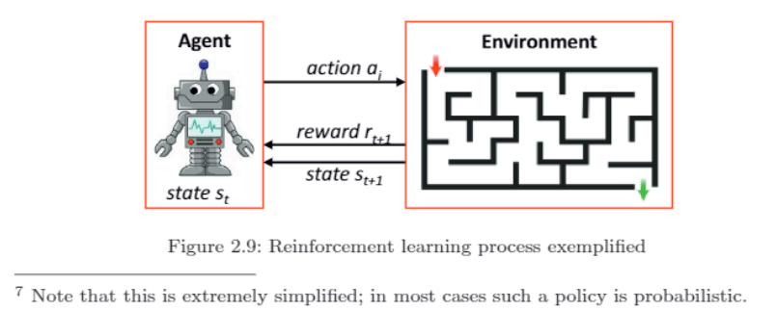

4. **Deep Learning**:

* Based on Artificial Neural Networks (ANN) with multiple layers (input, hidden, output).
* Uses large datasets and neural networks to recognize complex patterns.
* Learning happens via backpropagation, adjusting weights in the network.
* Deep learning uses thousands of layers and is useful for tasks like image recognition.
* 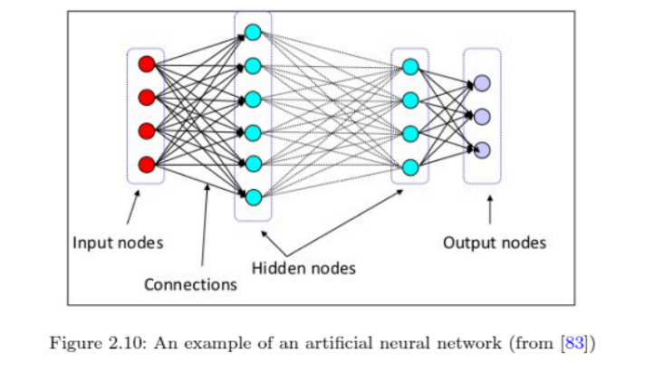

ISSUES IN MACHINE LEARNING

1. **Narrow Scope**:

* Machine learning success in specific tasks does not imply general intelligence.

2. **Dependence on Data**:

* Machine learning can only predict based on available data.
* Models may fail unpredictably, especially when data contains bias or is manipulated (e.g., image mislabeling).
* Models reflect the quality and context of training data (e.g., biases in data collection).

3. **Black-Box Effect**:

* Models often have complex parameters, making them hard to interpret.
* Decisions may lack clear explanations, leading to transparency issues.
* Context and biases of data collectors impact the model’s decisions.

INTERACTION

**interaction** in AI refers to the meaningful exchange and collaboration between AI systems and humans, or between different AI systems. It is the process where both parties adapt and respond to each other's actions, aiming to enhance decision-making and achieve goals that neither could accomplish alone. Interaction is crucial for combining the strengths and capabilities of both humans and machines, leading to better outcomes in various tasks.

Key points :

* **Collaboration**: Interaction allows AI and humans to work together, pooling their strengths for mutual benefit.
* **Dynamic Adaptation**: Each party (AI or human) modifies their actions based on the actions of the other.
* **Shift from Autonomy**: Unlike earlier AI systems that aimed to replace humans, modern AI focuses on working alongside humans.
* **Cobots (Collaborative Robots)**: AI systems are designed to interact like teammates, enhancing collaboration in real-world scenarios.
* **Natural Communication**: AI should use natural language and non-verbal cues to ensure smooth interaction and user satisfaction.

In summary, interaction in AI is the process of coordinated, dynamic, and collaborative engagement between AI and humans, enhancing outcomes through shared abilities and natural communication.

**Human-Machine Interaction**

**1. Categories of AI Systems:**

* **Virtual Agents:**
  + **Definition**: These are software systems that operate without a physical presence, interacting through computer interfaces. They include personal assistants, intelligent systems, networked multi-agent systems, and avatars in games.
* **Embodied Systems:**
  + **Definition**: These are physical artifacts embedding AI technology, equipped with sensors and effectors, and often capable of movement. They include robots, autonomous vehicles, and smart appliances.

**2. Human Dependency and Interaction:**

* **Increasing Dependence**: Humans are becoming more reliant on machines for everyday tasks such as route planning, managing schedules, and finding information. This increased reliance highlights the need for effective collaboration between humans and machines.
* **Conflicts**: Successful interaction requires more than just functional task division; it demands trust and acceptance of each other’s limitations. Machines must also provide explanations for their decisions to ensure transparency and maintain user trust.

**Affective Computing**

**1. Definition and Importance:**

* **Definition**: Affective computing focuses on enabling computers and robots to understand and respond to human emotions, providing emotional support and engaging in social interactions.
* **Importance**: Emotions play a crucial role in social interactions and help manage the complexity of these interactions. They are fundamental for meaningful human-computer interactions.

**2. Developments and Applications:**

* **Recent Advances**: **Interactive Toys**: For example, Adam et al.'s interactive toy uses emotional strategies to engage children in conversations.
* **Future Prospects**: Voice assistants like Alexa, Siri, and Google Home are evolving to understand and respond to emotions, leading to more emotionally aware systems outside research labs.

**3. Ethical Considerations:**

* **Debate on Emotions in AI**:
  + **Emotions as Human Traits**: Some argue that emotions are a defining human characteristic and that AI does not need to possess or recognize emotions to be effective.
  + **Machiavellian Intelligence Hypothesis**: Suggests that social competition drove the evolution of complex human intelligence, implying emotions are integral to intelligent systems.
* **Ethical Concerns**: There are significant ethical issues regarding privacy and the appropriateness of machines identifying or displaying emotions. The potential misuse and the impact on personal privacy raise questions about the development and deployment of affective computing systems.

**ETHICAL DECISION MAKING**

**Ethical Decision-Making** involves making choices that align with moral principles and values. In AI, it means designing systems that can incorporate ethical considerations into their decision-making processes, ensuring they act in ways that are just, fair, and respectful of human rights. This includes understanding different ethical theories and accounting for diverse cultural and individual values.

**ETHICAL THORIES**

1. **Meta-Ethics**:

* **Definition**: Investigates the nature, origin, and meaning of ethical principles. It seeks to understand what ethics is, the role of reason in ethical judgments, and whether there are universal human values.
* **Focus**: Examines questions about the essence of moral values and the basis of ethical beliefs.
* **Example**: A meta-ethical inquiry might explore whether moral judgments are subjective (based on personal feelings) or objective (based on universal standards).

2. **Applied Ethics**:

* **Definition**: Applies ethical principles to practical and controversial issues, such as euthanasia, animal rights, and environmental concerns.
* **Focus**: Addresses specific ethical dilemmas and how moral considerations can be applied in real-world scenarios, including the behavior of artificial systems.
* **Example**: Applied ethics would address the morality of using AI to make decisions in healthcare, such as whether it is ethical to use AI to prioritize patients for treatment based on their predicted outcomes.

3. **Normative Ethics**:

* **Definition**: Aims to establish standards for how people ought to act by developing rules that govern human conduct.
* **Focus**: Determines what is right or wrong and how ethical principles should be applied in different situations.
* **Key Theories**:
  + **Consequentialism**:
    - **Definition**: Argues that the morality of an action is determined by its outcomes or results. The best action is the one that produces the most favorable consequences.
    - **Key Example**: **Utilitarianism**, a type of consequentialism, suggests that actions are right if they maximize overall well-being. For example, a policy that allocates medical resources to the greatest number of people to maximize overall health benefits would be supported by utilitarianism.
    - **Questions**: What constitutes good consequences? How are these consequences assessed?
  + **Deontology**:
    - **Definition**: Judges the morality of an action based on adherence to rules and duties rather than outcomes. Focuses on whether actions align with moral principles.
    - **Key Example**: **Kant’s Categorical Imperative**, which asserts that one should act according to maxims that could be universal laws. For instance, it would be wrong to lie, even if it might lead to a better outcome, because lying cannot be universalized as a moral law.
    - **Questions**: What are the fundamental rules or duties? How should decisions be made according to these rules?
  + **Virtue Ethics**:
    - **Definition**: Concentrates on the character of the person performing an action rather than the nature or consequences of the action itself. Stresses developing good character traits.
    - **Key Example**: **Aristotle’s concept of eudaimonia (happiness or welfare)**, where virtues like courage and generosity are crucial. For instance, a virtuous person would help others in need out of a habit of kindness, rather than calculating the outcome.
    - **Questions**: What virtues are essential? How do they contribute to a good life?

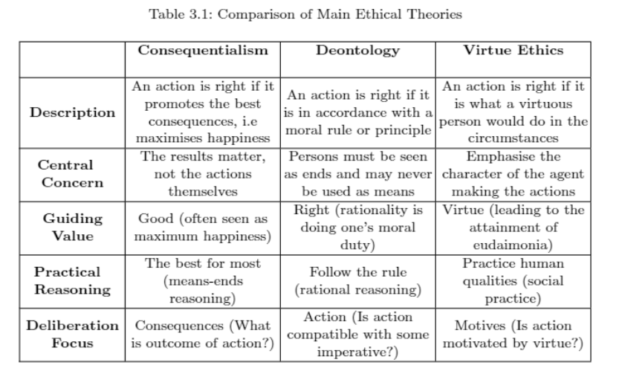

4. **Additional Theories**:

* **Principle of Double Effect (DDE)**:
  + **Definition**: Justifies actions that cause harm if the harm is an unintended side effect of achieving a good outcome.
  + **Focus**: Evaluates the intention behind actions and distinguishes between intended and unintended consequences.
  + **Example**: Administering strong painkillers to a terminally ill patient may hasten death, but if the primary intent is to relieve suffering, it may be justified under DDE.
* **Human Rights Ethics**:
  + **Definition**: Asserts that human rights are inherent and absolute, not subject to utilitarian calculations.
  + **Focus**: Upholds the intrinsic value of each individual, emphasizing that rights should not be violated even for the greater good.
  + **Example**: A law permitting the shooting down of a hijacked plane to protect others would be unacceptable under Human Rights Ethics because it violates the fundamental right to life of the passengers.
* **Principle of Lesser Evils**:
  + **Definition**: Suggests choosing the lesser of two evils when faced with a moral dilemma.
  + **Focus**: Orders actions or situations according to moral value, aiming to minimize harm even if it means compromising on some moral principles.
  + **Example**: In a situation where lying is the only way to prevent significant harm, such as deceiving a criminal to protect a victim, the Principle of Lesser Evils might justify the lie.

**VALUES**

Values are essential in ethical reasoning, guiding human decision-making by determining which moral principles to prioritize in different situations. According to Schwartz, values are fundamental goals that motivate actions and are broader than specific actions or circumstances. They have two core properties:

1. **Genericity**: Values are broad and can be applied to various situations. For instance, the value of "health" can be reflected in behaviors like eating well, exercising, and managing stress.
2. **Comparison**: Values allow for the comparison of different situations based on their alignment with these values. For example, choosing a salad over pizza might be preferred if the value of health is prioritized.

Values are abstract and context-independent, making them difficult to measure directly. Instead, they are evaluated through their practical application. For instance, the value of "wealth" can be indirectly measured by the amount of money one has, even though wealth encompasses more than just monetary assets.

**Contradictions**: Values can sometimes conflict with each other. For example, prioritizing environmental care by cycling to work might lead to being unprofessional at a meeting due to being soaked from the rain.

To manage these contradictions, values are organized in two ways:

1. **Relative Relation**: Values are positioned relative to each other, as shown in Schwartz’s circle of values. For instance, "achievement" (self-enhancement) and "benevolence" (self-transcendence) can be in conflict. Maximizing personal profit by paying low wages benefits the employer but harms employees.
2. **Personal Preference**: Individuals and cultures prioritize values differently. People will often choose options that align with their most important values. For example, if health is more crucial to you than wealth, you might choose healthier, albeit more expensive, food.

Schwartz identifies ten basic values classified into four dimensions:

* **Openness to Change**: Self-Direction and Stimulation
* **Self-Enhancement**: Hedonism, Achievement, and Power
* **Conservation**: Security, Conformity, and Tradition
* **Self-Transcendence**: Benevolence and Universalism

Understanding these value systems is crucial for determining ethical decisions, especially when designing AI systems that need to reflect societal values and priorities.

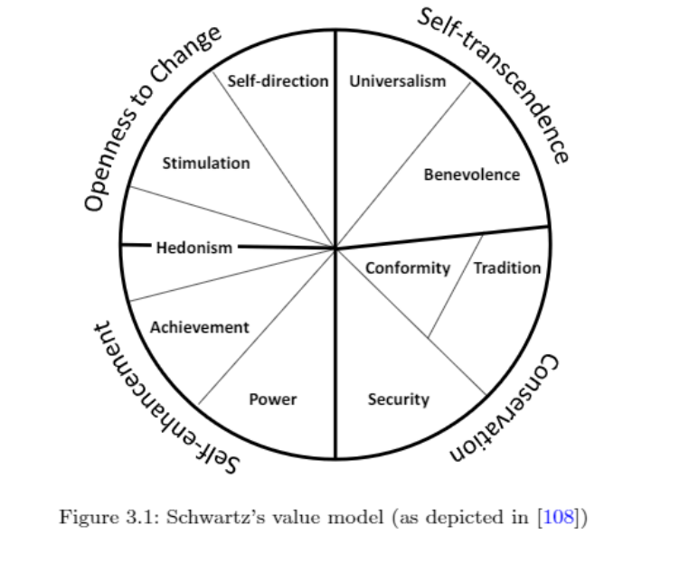

**Ethics in Practice**

Ethical reasoning becomes critical when faced with **moral dilemmas**—situations where moral requirements conflict, and no clear solution exists that fully satisfies both sides.

In these scenarios, each choice has its own moral justification, and people may make different decisions based on their ethical perspectives.

For AI systems, this complexity grows, as they will eventually face real-world dilemmas that demand some level of ethical reasoning.

**Trolley Problem Example:**

* Classic moral dilemma: A runaway trolley is headed towards five people.
* Observer can pull a lever to divert it, killing one person instead of five.
* AI systems, like self-driving cars, may face similar dilemmas (e.g., harming passengers or pedestrians).

**Other AI Dilemmas:** This kind of dilemma extends beyond autonomous vehicles. For example:

* **Intelligent Medicine Dispensers**: Deciding which patient to prioritize when medicine is scarce.
* **Search-and-Rescue Robots**: Deciding which victims to rescue first in emergencies.
* **Health-Care Robots**: Choosing between respecting a user's preferences or providing optimal care.

**Ethical Theories in AI Decision-Making**

Different ethical theories guide AI decisions in dilemmas:

1. **Consequentialism (Utilitarianism)**: Focuses on outcomes. The AI would choose the option that saves the most people, even if it means actively causing harm to a few. For example, it might swerve to save more pedestrians, even if it harms passengers.

• **Example**: A self-driving car swerves to hit one pedestrian instead of five passengers, aiming to minimize the total number of casualties.

1. **Deontology (Kantian Ethics)**: Focuses on the morality of actions. The AI would avoid taking actions that directly cause harm, even if that means more people get hurt. It may not swerve if it believes swerving is wrong, even if that leads to more casualties.

• **Example**: The car chooses not to swerve, as swerving would be a deliberate action that causes harm, even though it might save more people.

1. **Virtue Ethics**: Focuses on motives. The AI would act as a virtuous person would, possibly protecting the most vulnerable (like pedestrians) over passengers, as they are less protected.

**Example**: The car swerves to protect pedestrians because they are more vulnerable than the passengers, even though this could result in harm to the passengers.

**Prioritizing Values**

AI decisions depend on value prioritization. For example, an AI valuing **health** might prioritize optimal care, while one valuing **autonomy** would respect a patient's wishes. Similarly, in dilemmas, how values like **pleasure** or **universal well-being** are prioritized affects outcomes.

**Implementing Ethical Reasoning in AI**

Ethical reasoning in AI faces numerous challenges because current systems lack essential human qualities like regret and creativity. However, to implement such reasoning, AI systems would need to follow a structured process, though most of the steps involved remain beyond today's AI capabilities.

Here’s an overview of how this reasoning could work:

1. **Recognizing an Event**: The AI must first identify that a situation requires action based on input from its sensors. For example, a self-driving car might detect an obstacle in its path. Ideally, the system would need advanced perception to distinguish if it's a person, an object, or an animal, but such detailed analysis is not fully achievable yet.
2. **Identifying Ethical Dimensions**: Once the event is recognized, the AI must assess its ethical implications. It should evaluate who will be affected by its actions and analyze the consequences, both positive and negative. This requires vast data and sophisticated reasoning, especially in terms of predicting outcomes.
3. **Taking Responsibility**: The AI must decide whether to act on its own or involve a human, like notifying road authorities in case of an obstacle. This is part of the “human-in-the-loop” concept, which can be explored further in ethical dilemmas.
4. **Applying Ethical Principles**: The AI will then analyze what ethical rules or codes apply, ensuring fairness and justice while avoiding biases. For example, in the case of a self-driving car, it might assess the rights of the passengers versus pedestrians.
5. **Generating and Implementing Solutions**: After evaluating all factors, the AI must come up with a solution based on the ethical theories it follows (e.g., maximizing benefits in a consequentialist way) and act upon it.

**Computational Complexity of Ethical Theories**

1. **Consequentialist AI**: It must evaluate the potential outcomes of each action, often using game theory or simulations to predict consequences. This requires heavy computation because consequences are nearly infinite in scope.
2. **Deontological AI**: These systems focus on duties and rules. They use reasoning about actions and their consistency with moral laws, often utilizing formal methods like Deontic logic to determine the right course of action.
3. **Virtue Ethics AI**: More complex as it must analyze motives and how a virtuous person would react in the situation. This often involves modeling human-like reasoning (Theory of Mind) to predict the impact of actions on others.

These approaches illustrate the difficulty of implementing ethical reasoning in AI, as each theory has different computational requirements and complexities.

**Taking Responsibility**

Responsible Research and Innovation

Responsible Research and Innovation (RRI) is a framework that ensures the research and innovation process aligns with societal values and expectations. It involves all societal actors—such as researchers, policymakers, and citizens—in a continuous, transparent process that considers the environmental, social, and ethical impacts of new technologies throughout their development and deployment.

Understanding the RRI Process:

• **Diversity and Inclusion**: Involve a wide range of stakeholders early in the innovation process, and ensure diversity within development teams to bring in various perspectives and expertise.

• **Openness and Transparency**: Maintain clear communication about project details, including funding, decision-making processes, and governance. Openly share data and results to build public trust and allow for critical review.

• **Anticipation and Reflexivity**: Consider the environmental, economic, and social impacts of research and innovation. Reflect on personal and institutional values, assumptions, and responsibilities.

• **Responsiveness and Adaptiveness**: Adapt to new knowledge, data, and perspectives. Engage continuously with stakeholders and be willing to adjust roles and responsibilities based on emerging insights and norms.

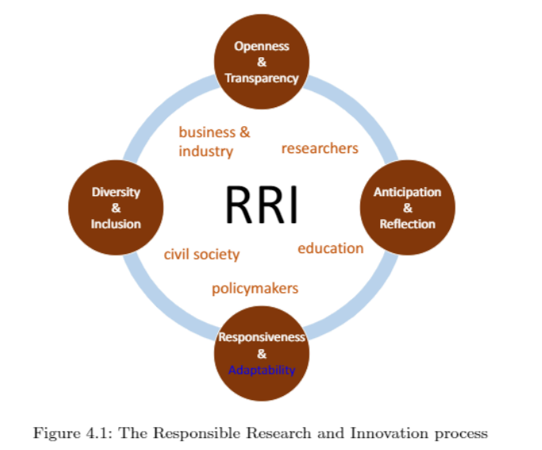

**The ART of AI:**

**Accountability, Responsibility, Transparency**

The ART principles—Accountability, Responsibility, and Transparency—are crucial for developing trustworthy AI systems that align with societal values and ethical standards.

**Accountability** ensures that AI systems can explain and justify their decisions. For instance, if a credit scoring AI denies a loan application, it must provide a clear explanation based on the evaluated factors. Accountability also involves involving stakeholders in setting the ethical values and norms that guide AI decisions. For example, community feedback sessions can help ensure that an AI tool used in public policy reflects societal values.

**Responsibility** pertains to clarifying the roles and duties of individuals involved with AI systems. This includes defining who is liable for the decisions made by AI and their consequences. In the case of autonomous drones used for delivery, responsibility lies with both the manufacturers and operators to ensure safe operations. Additionally, responsibility involves establishing protocols to track and attribute AI decisions, such as logging mechanisms in AI trading systems to ensure compliance with financial regulations.

**Transparency** requires making the data sources, decision-making processes, and learning mechanisms of AI systems open and understandable. For example, a health app using AI should disclose how it processes user data and the algorithms behind its recommendations. Transparency also involves providing clear information about how AI systems learn and adapt over time, like a language translation app explaining its improvement process based on user interactions.

These principles collectively guide the design and deployment of AI systems, ensuring they operate responsibly and align with both ethical considerations and societal expectations.

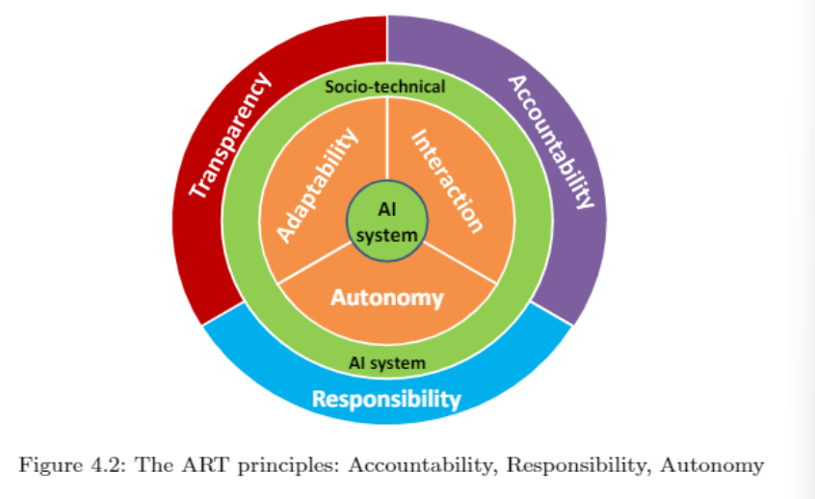

**Accountability**

Accountability is essential for responsible AI development. It encompasses the system's ability to explain and justify its decisions and actions. Two key aspects of accountability are:

1. **Explanation of Actions:**
   * **Importance:** AI systems must provide clear explanations for their decisions to build trust. This transparency helps users understand the system's behavior and limitations. For example, if an AI-powered diagnostic tool identifies a disease, it should explain the factors leading to its diagnosis, such as specific symptoms or test results.
   * **Post-Mortem Analysis:** In case of errors, explanation mechanisms such as logging systems (similar to aviation black boxes) help investigators understand what went wrong. This is crucial for improving the system and preventing future issues.
2. **Design Process Transparency:**
   * **Design Rationale:** The design of an AI system must be transparent, reflecting societal, ethical, and legal considerations. Decisions made during design influence how the system functions and impacts society. For instance, if an AI is designed for hiring, its design choices should consider fairness and non-discrimination.

**Responsibility in AI Systems**

The increasing presence of AI in daily life raises critical questions about responsibility for decisions made by AI systems. As AI systems gain autonomy and learning capabilities, we must ask: Who is responsible for their decisions, and how can we ensure ethical outcomes?

Despite their autonomy, AI systems remain tools created by humans for specific purposes. Even if an AI system is designed for transparency and accountability, the responsibility for its actions ultimately lies with the humans who built, designed, and use the system. While AI systems can learn from their environment and modify their behavior, they do so based on their original design and purpose.

Current discussions on AI responsibility often revolve around two scenarios:

1. **AI acts as intended**: The responsibility lies with the user.
2. **AI acts unexpectedly**: Developers or manufacturers are held liable for malfunctions or errors.

**Legal and Regulatory Concerns**  
Responsibility for AI also ties into legal frameworks, particularly around product liability. Courts and governments play a role in determining accountability in cases where AI systems malfunction or cause harm. While current product liability laws offer some guidance, there are growing calls to develop AI-specific regulations. A notable example is the European Parliament's 2017 proposal to establish legal personhood for robots. This proposal was controversial, as many experts warned that it overestimated AI’s current capabilities and conflicted with human rights frameworks.

**Design and Human-Likeness in AI**  
Another aspect of responsibility involves the design of AI systems with human-like characteristics. Anthropomorphizing AI systems, such as Google's Duplex or Hanson Robotics' Sophia, can lead to unrealistic expectations about their capabilities. When AI systems resemble humans, designers must take extra care, particularly when the systems interact with vulnerable groups like children or the elderly. Impersonating human identities through AI design may also lead to legal issues and liability for developers.

In conclusion, responsibility in AI touches on ethical, legal, and design concerns, emphasizing the role of humans in ensuring that AI systems are used ethically and responsibly.

**Transparency in AI Systems**

**Transparency** is a critical principle for understanding and managing AI systems, ensuring that their decisions and operations are visible and comprehensible to users, regulators, and those impacted by the technology. Here's a breakdown of the key aspects related to transparency in AI:

**Challenges to Transparency**

1. **Black-Box Problem**: Many machine learning algorithms are complex and function as "black boxes," meaning their decision-making processes are not easily understood by users. While making code and data open for inspection might seem like a solution, it often violates intellectual property and can be too technical for most users.
2. **Bias and Data Issues**:
   * **Bias in Data**: Data used for training AI systems often reflect societal biases, which can lead to biased decision-making by the AI. For instance, algorithms might inadvertently reinforce racial or socioeconomic biases present in the data.
   * **Challenges in Removing Bias**: Even if algorithms are transparent, removing bias is complex due to the inherent biases in human-generated data and the difficulty in defining and measuring different forms of bias.
3. **Data and Governance**:
   * **Data Openness**: Transparency requires that stakeholders understand what data is used, how it is governed, and whether it is representative of the context in which the AI operates.
   * **Data Quality**: Issues such as outdated data, incompleteness, and bad governance can further complicate transparency efforts.

**Promoting Transparency**

1. **Openness About Data**:
   * **Types and Sources**: Clearly document the types of data used for training and decision-making. Ensure data resembles the context of use and is well-governed.
   * **Data Characteristics**: Provide information on the data's age, source, and updates. Make data available for replication studies if possible.
2. **Openness About Design Processes**: Record and disclose assumptions, choices, and reasons behind design decisions. Detail who makes these decisions and how they are determined.
3. **Openness About Algorithms**: Define and justify the criteria for optimizing decisions. Address potential biases and steps taken to prevent them.
4. **Openness About Actors and Stakeholders**: Identify who is involved in the development and their interests. Ensure transparency in user participation and funding sources.

**Rethinking Optimization Criteria**

* **Shift in Focus**: To enhance transparency, there needs to be a shift from optimizing solely for functional performance to ensuring that ethical principles and human values are at the core of AI design.
* **Regulation and Education**: Regulatory frameworks can enforce transparency, and education can support a cultural shift towards prioritizing transparency in AI development.

By applying systematic and methodical approaches to AI development, such as those used in software engineering, and focusing on transparency, the goal is to create more accountable and ethical AI systems.

**What Is an Ethical Action?**

To determine if we can implement ethical agents, we first need a formal computational definition of an ethical action. Dennett [36] outlines three requirements for an action to be considered ethical:

1. **Choice Between Actions:** The agent must have the ability to choose between different actions.
2. **Societal Consensus:** There must be some societal agreement that at least one of the possible choices is socially beneficial.
3. **Recognition and Decision:** The agent must recognize the socially beneficial action and explicitly choose it because it is the ethical thing to do.

**Naive Approach:** A simple approach to designing an ethical agent might include:

* **Action Set Identification:** Assume the agent can identify all possible actions at any time.
* **Action Labeling:** Label each action with its 'ethical degree' in the current context (e.g., a scale from 0 to 1).
* **Algorithm Implementation:** Use the labels to choose the most ethical action.

**Challenges with the Naive Approach:**

* **Action Identification and Labeling:** It's impractical to always identify all possible actions and accurately label them with their ethical degree.
* **Social Consensus:** Achieving societal consensus on ethical standards is challenging. Ethical theories differ, and even within groups, there may be disagreements.
* **Ethical Theory Implementation:** Implementing ethical theories in AI systems is complex. For example, utilitarianism or deontological ethics requires different approaches.

**Ethical Theories and Computational Demands:**

1. **Deontological Ethics:**
   * Focuses on actions themselves, which can be approached by a labeling system as in Algorithm 1.
   * Uses predefined rules to determine the ethical degree of actions.
2. **Consequentialist Ethics:**
   * Focuses on the outcomes of actions.
   * Requires the agent to simulate potential outcomes and calculate their ethical value.
3. **Virtue Ethics:**
   * Focuses on character and motives.
   * Difficult to implement as it relies on relational decisions and examples of virtuous behavior.

**Conclusion:** Designing an AI system that can reason about ethics is complex due to the variability in ethical theories and societal norms.

**Approaches to Ethical Reasoning by AI**

**Top-Down Approaches**

**What Are Top-Down Approaches?**

**In AI (Artificial Intelligence), a "top-down approach" to ethical reasoning means starting from predefined ethical rules or theories and using these rules to guide an AI system's actions. The idea is that the system follows ethical guidelines that are already established, much like how a human might follow a moral code.**

**Key Components of Top-Down Approaches:**

1. **Ethical Theories: These are different ways to define what is "right" or "wrong" in a situation. Some common ethical theories used in AI include:**
   * **Utilitarianism: This theory focuses on achieving the greatest good for the most people. The AI tries to make decisions that maximize positive outcomes for everyone.**
   * **Deontological Ethics: This theory focuses on following rules or duties. In this case, the AI makes decisions based on whether the action follows a set rule, regardless of whether the result is good or bad.**
2. **Computational Requirements: These are the things an AI system needs to apply these ethical theories:**
   * **Representation Languages: These are tools that allow the AI to understand and connect its actions with ethical rules.**
   * **Planning Mechanisms: The AI needs ways to plan its actions based on the ethical rules it's following.**
   * **Deliberation Capabilities: The AI must think about whether a situation requires ethical decision-making and then choose the appropriate action.**

**Examples of Top-Down Approaches:**

* **Deontic Logics: These are formal systems that help model ethical concepts like "obligations" (things the AI must do) and "rights" (things the AI must respect).**
* **Internal Representation: Some systems give the AI an internal ethical framework so it can evaluate its own actions and decide whether they're ethical or not.**

**Reflection on Top-Down Approaches:**

1. **Ethics vs. Law:**
   * **Difference Between Law and Ethics: Top-down approaches often treat ethical decisions as if they are as clear as legal rules, but ethics are more complex. Something may be legal but not ethical, and top-down systems might mix up the two.**
2. **Challenges:**
   * **Value Determination: It's hard to decide what moral values the AI should follow. For example, if the AI follows utilitarianism, how does it decide what is the "best" outcome for everyone? People's values (like focusing on health, wealth, or the environment) might differ.**
   * **Complexity in Real-Life: Real-world situations are often too complicated for simple ethical rules. The AI may struggle with cases that don’t fit neatly into predefined rules.**
3. **Soft Ethics:**
   * **Soft Ethics refers to an AI system not just following legal rules but also considering moral guidelines that might not be part of the law. The AI should act ethically, even if the law does not explicitly say how to handle a situation.**

**Summary:**

**Top-down approaches use pre-established ethical theories to guide AI decisions, but they require complex systems to work effectively. The main challenge is that real-world situations often require more flexibility than these systems allow, and they must navigate the difference between legal compliance and ethical behavior. Integrating "soft ethics" allows the AI to aim for both legal and moral standards.**

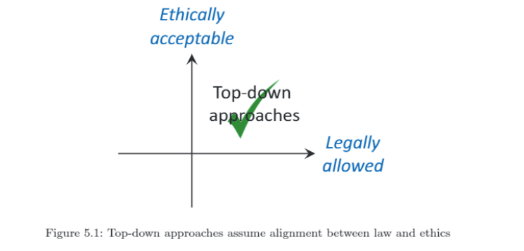

**Bottom-Up Approaches**

**Definition and Mechanism:**

Bottom-up approaches to ethical reasoning focus on learning ethical behavior from the observation of others. The core idea is that ethical competence is developed by observing and learning from societal norms and practices, similar to how children learn ethics from their environment. These approaches leverage social data to guide decision-making processes.

**Key Components:**

1. **Learning Mechanism:**
   * **Observation and Learning:** Agents observe the behavior of others to infer what is considered ethical or unethical. This process involves constant learning and adapting based on observed social norms and outcomes.
   * **Moral Foundations Questionnaire:** Studies like those conducted by Malle use tools like the Moral Foundations Questionnaire to gauge societal opinions on ethical principles such as harm, fairness, and authority.
2. **Implementation Example:**
   * **Societal Preferences Model:** An example described in [96] involves agents learning societal preferences and aggregating them to make decisions in ethical dilemmas. This method uses voting rules to determine the most socially acceptable choice.

**Reflection on the Bottom-Up Approach:**

1. **Social vs. Moral Acceptability:**
   * **Social Acceptance:** Bottom-up approaches assume that social acceptance (i.e., what is generally accepted by society) reflects ethical acceptability. However, social acceptance is an empirical fact, while moral acceptability involves ethical judgment.
   * **Discrepancies:** There can be a disconnect between what is socially accepted and what is morally acceptable. For instance, certain behaviors might be socially accepted but ethically questionable (e.g., tax avoidance), while other morally acceptable actions might be socially rejected due to perceived costs or inconveniences (e.g., vegetarianism, supporting refugees).
2. **Challenges and Pitfalls:**
   * **Cultural and Contextual Dependence:** Consensus on ethical behavior is often context-dependent and influenced by cultural norms. What is considered ethical in one culture might not be seen the same way in another.
   * **Crowd Wisdom Limitations:** While crowd-based decisions can reflect social norms, they may not always align with ethical standards. For example, popular opinions can sometimes support ethically dubious practices if they are widely accepted (e.g., speeding).
   * **Conflicting Opinions:** Ethical debates often involve conflicting viewpoints, each supported by valid moral arguments. For example, debates on school nutrition can involve equally valid arguments for both healthy living and freedom of choice.

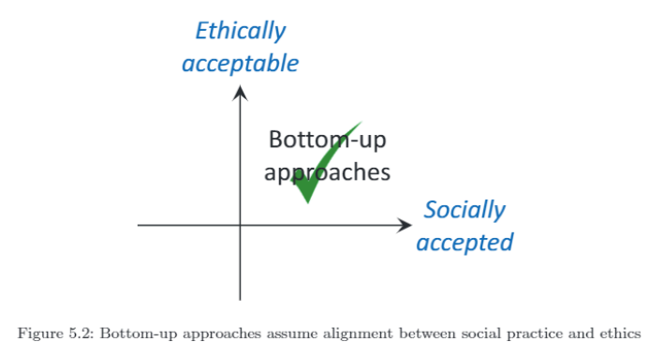

**Summary:**

Bottom-up approaches rely on observing and learning from societal behavior to inform ethical decision-making. While this method captures social norms and preferences, it may not always align with moral acceptability. The approach faces challenges related to cultural differences, the limitations of crowd wisdom, and conflicting ethical viewpoints. Balancing social acceptance with ethical judgment is crucial for effective implementation of bottom-up ethical reasoning.

**Hybrid Approaches**

**Definition and Overview:**

Hybrid approaches aim to merge the strengths of both top-down and bottom-up methods to achieve ethical reasoning in AI systems. By integrating programmed rules (top-down) and context-based observations (bottom-up), these approaches seek to ensure that AI systems act in ways that are both legally compliant and socially acceptable.

**Key Concepts:**

1. **Nature and Nurture:**
   * **Nature (Top-Down):** Incorporates pre-defined ethical rules and principles, akin to programmed moral guidelines.
   * **Nurture (Bottom-Up):** Relies on observing and learning from social context and behavior to adapt ethical judgments.
2. **Pragmatic Social Heuristics:**
   * **Gigerenzer's View:** Moral behavior is shaped by both inherent rules and environmental influences. A hybrid approach reflects this interplay by combining structured ethical rules with contextual learning.

**Examples of Hybrid Approaches:**

1. **Conitzer's Approach:**
   * **Integration of Paradigms:** Combines game-theoretic concepts with machine learning. This involves extending game theory to include ethical dimensions and using human-labeled data to train models on moral decision-making.
2. **OracleAI System:**
   * **Application:** Demonstrates a practical implementation of combining programmed ethics with observed social behaviors.
3. **MOOD (Multi-Objective Optimization for Decision-making):**
   * **Collective Intelligence:** MOOD integrates diverse perspectives and ensures that all design decisions are explicit and queryable.
   * **Ethical Deliberation:** It balances majority and minority viewpoints, considering fairness, distribution of costs and benefits, potential harm, and other ethical factors.

**Reflection on the Hybrid Approach:**

1. **Advantages:**
   * **Combining Strengths:** Hybrid approaches leverage the strengths of both top-down and bottom-up methods, aiming to cover gaps that each approach alone might miss.
   * **Broad Perspective:** By incorporating multiple viewpoints and ethical considerations, hybrid approaches strive for decisions that are fair and widely accepted.
2. **Challenges:**
   * **Complexity:** Integrating both programmed rules and contextual learning can be complex and may require sophisticated systems to manage and balance both aspects.
   * **Ethical Justness:** While hybrid approaches aim to be ethically just, defining and measuring ethical acceptability remains challenging. Ensuring that all relevant perspectives are considered and integrated effectively can be difficult.
3. **MOOD's Contribution:**
   * **Facilitation of Debate:** MOOD promotes discussions that include a wide range of perspectives, aiming for stable and sustainable outcomes that are broadly accepted.
   * **Ethical Justness:** It emphasizes the fairness and ethical implications of decisions, providing insights into their justness rather than simply dictating choices.

**Summary:**

Hybrid approaches to ethical reasoning in AI systems blend the structured, rule-based nature of top-down methods with the adaptive, context-sensitive aspects of bottom-up approaches. By integrating both perspectives, these approaches aim to achieve ethical decision-making that is both legally compliant and socially acceptable. While hybrid methods offer a comprehensive way forward, they also face challenges related to complexity and the measurement of ethical justness. Models like MOOD represent efforts to balance diverse viewpoints and ensure fairness in decision-making.

**Designing Artificial Moral Agents**

**Overview:**

Designing AI systems with ethical reasoning capabilities is complex and requires careful consideration of several factors. The process involves addressing questions about the necessity and feasibility of such systems, and ensuring their alignment with societal and ethical principles.

**Key Considerations:**

1. **Should We Develop Such Systems?**
   * **Evaluation:** Before developing artificial moral agents, it is crucial to assess if the benefits of such systems outweigh the complexities and potential risks.
2. **Guidelines for Responsible Design:**

**a. Value Alignment:**

* + **Values Pursued:** Identify and articulate the ethical principles and human values the system should uphold.
  + **Stakeholder Involvement:** Ensure diverse stakeholder participation in defining these values. Document how opinions are gathered and decisions are made.
  + **Regulatory Alignment:** Align the system with existing regulations and norms.
  + **Prioritization:** Explicitly state how conflicting values (e.g., safety vs. privacy) are prioritized.

**b. Ethical Framework:**

* + **Ethical Theories:** Decide on the ethical theories the system will follow and justify the choice.
  + **Conflict Resolution:** Implement mechanisms for handling value conflicts and making reasoned choices.

**c. Implementation:**

* + **Autonomy Level:** Define the system's autonomy in decision-making and the circumstances under which it should defer to human judgment.
  + **Roles:** Clarify the roles of users and governing institutions in the decision-making process.

**5.4.1 Who Sets the Values?**

**Importance of Participation:**

* **Diverse Input:** Gather input from all relevant stakeholders and ensure representation from diverse groups to avoid biases.
* **Crowd and Choice:** Consider the diversity of the crowd and the nature of the choice offered. Avoid oversimplified binary choices that may not capture the complexity of ethical decisions.

**Considerations in Value Setting:**

1. **Crowd:**
   * **Stakeholder Representation:** Ensure all affected parties are represented.
   * **Bias Awareness:** Address potential biases in the collected data and decision-making processes.
2. **Choice:**
   * **Binary vs. Spectrum:** Recognize that binary choices can oversimplify complex decisions. Provide a spectrum of options when possible.
3. **Information:**
   * **Question Framing:** Be aware of how questions and information framing can influence decisions. Use clear and neutral language to avoid misleading respondents.
4. **Involvement:**
   * **Affected Parties:** Ensure that those most affected by decisions have adequate representation and consideration.
5. **Legitimacy:**
   * **Majority Decisions:** Address concerns about the legitimacy of decisions, especially when margins are narrow.
6. **Electoral System:**
   * **System Design:** Understand how the electoral system impacts results. Consider how different systems (e.g., plurality vs. proportional) might influence outcomes.

**Value Prioritization:**

* **Individual vs. Societal Values:** Recognize that values are subjective and can vary across cultures and individuals. Develop systems that respect and integrate these differences.
* **Normative Interpretations:** Define concrete functionalities based on the normative interpretations of abstract values.

**Hybrid Approach:**

* **Formal Structures:** Utilize formal structures for collective deliberation to ensure that decisions are based on long-term goals and shared values.
* **Deliberative Democracy Characteristics:**
  + **Information:** Provide accurate and relevant data.
  + **Substantive Balance:** Compare positions based on evidence.
  + **Diversity:** Include all major relevant positions.
  + **Conscientiousness:** Sincerely weigh all arguments.
  + **Equal Consideration:** Weigh views based on evidence, not advocacy.

**Additional Principle:**

* **Openness:** Ensure transparency in the design and implementation processes, making options and decisions clear and accessible.

This approach aims to ensure that artificial moral agents are designed with a comprehensive understanding of ethical principles, stakeholder involvement, and regulatory requirements, leading to systems that are responsible, fair, and aligned with societal values.

**Implementing Ethical Deliberation**

**Overview:**

In AI ethics, implementing ethical deliberation involves deciding how AI systems will handle moral reasoning. The complexity of this task often requires considering various approaches to integrate ethical decision-making into AI systems. Here are four main approaches to designing decision-making mechanisms for autonomous systems:

**1. Algorithmic Approach:**

* **Objective:** Integrate moral reasoning into the system's decision-making algorithms.
* **Implementation:** The AI system autonomously evaluates the moral and societal consequences of its decisions. This requires:
  + **Complex Algorithms:** Advanced decision-making algorithms capable of real-time ethical reasoning.
  + **Moral Principles:** Incorporating principles regarding right and wrong and providing qualitative explanations of the system's beliefs and decisions.
* **Challenges:** High complexity and the need for real-time processing.

**2. Human-in-Command:**

* **Objective:** Involve humans in the decision-making process, either as supervisors or as those under supervision.
* **Collaboration Types:**
  + **Autopilot:** The AI system is in control, and the human supervises.
  + **Guardian Angel:** The AI system supervises human actions.
* **Design Requirements:**
  + **Shared Awareness:** Ensure that humans have enough information to intervene effectively.
  + **Interactive Control:** Use human-in-the-loop control systems to facilitate human oversight.
* **Challenges:** Requires effective communication and shared understanding between humans and AI systems.

**3. Regulation:**

* **Objective:** Design the environment or system infrastructure to avoid moral dilemmas.
* **Implementation:**
  + **Regulated Environment:** The environment is designed to constrain the system's actions, avoiding situations that require moral decisions.
  + **Example:** Smart highways where infrastructure controls vehicle behavior, reducing the need for moral decision-making by AI.
* **Challenges:** Limited flexibility in decision-making and reliance on regulatory design.

**4. Random Approach:**

* **Objective:** Allow the AI system to make random decisions when faced with moral dilemmas.
* **Implementation:**
  + **Random Choice:** In situations where choosing between two wrongs is problematic, the system randomly selects an action.
* **Considerations:**
  + **Human Behavior:** Similar to human behavior under time pressure where decisions are made based on justice and fairness rather than careful reasoning.
  + **Research Needs:** Understand the acceptability and effectiveness of random decision-making approaches.
* **Challenges:** May lack predictability and consistency.

**Cultural and Societal Considerations:**

* **Value Prioritization:** Different societies interpret values differently, influencing the suitability of each approach.
  + **Conformity Societies:** May prefer regulatory approaches where ethical norms are enforced by legal and institutional frameworks.
  + **Egalitarian Societies:** Might be more open to random decision-making mechanisms, as they avoid making explicit value judgments.

**Methodologies for Design for Values:**

* **Design for Values:** To ensure that the chosen implementation approach aligns with the values and priorities of designers and stakeholders, methodologies from Chapter 3 should be used to make values and priorities explicit.

This section emphasizes the importance of selecting an appropriate approach to ethical deliberation based on the specific context, societal values, and the nature of the decision-making required for AI systems.

**Levels of Ethical Behaviour**

**Overview:**

As AI systems evolve and gain more autonomy and social awareness, our perceptions of them are changing. Instead of merely being viewed as tools, AI systems are increasingly seen as team members or companions. This shift impacts expectations about their ethical behavior and responsibility.

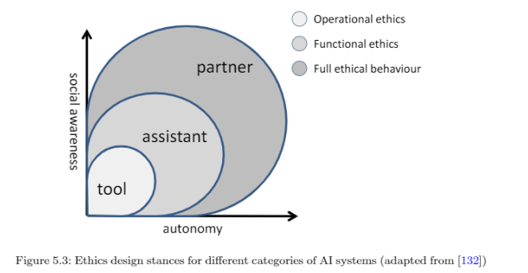

**Levels of Ethical Behaviour:**

1. **Tools:**
   * **Characteristics:** These are systems with no or very limited autonomy and social awareness. Examples include simple devices like hammers or search engines.
   * **Ethical Considerations:** They are not considered ethical systems in themselves but may incorporate values implicitly through their design, leading to different behaviors.
2. **Assistants:**
   * **Characteristics:** These systems have limited autonomy but are aware of their social environment. They can evaluate norms and adjust actions accordingly.
   * **Functional Morality:** Responses to ethically relevant features are hard-wired into the system architecture. Assistants can decide whether to comply with or deviate from norms.
   * **Examples:** Virtual assistants that adjust their behavior based on user interactions and social context.
3. **Artificial Partners:**
   * **Characteristics:** Full moral agents capable of self-reflection, reasoning, arguing, and adjusting their moral behavior.
   * **Current Status:** These systems are primarily fictional (e.g., Data from *Star Trek* or Ava from *Ex Machina*). Many scholars argue that such agents remain speculative.

**Expectations and Accountability:**

* **Social Awareness and Autonomy:** As AI systems become more autonomous and socially aware, expectations about their behavior, responsibility, and accountability increase.
* **Explanation and Accountability:** Ethical behavior by AI should include the ability to explain decisions and actions to others. This is crucial for accountability and involves:
  + **Explaining Rationale:** Being able to articulate why decisions were made.
  + **Influence by Explanations:** Ability to adjust behavior based on feedback from others.

**Challenges in Explainability:**

* **Deep Learning Algorithms:** These algorithms often optimize for functional performance, resulting in "black box" systems that provide no insight into their decision-making processes.
* **Explanation Methods:**
  + **Evolutionary Ethics:** Applying principles from evolutionary ethics to create explanation methods.
  + **Structured Argumentation Models:** Using models to structure and present explanations.
  + **Goal-Plan Models:** Implementing models that align goals with planned actions.
  + **Pragmatic Social Heuristics:** Based on heuristics instead of moral rules, integrating ethical rules with context adaptation.

**Shifting Focus in AI Design:**

* **Optimization Criteria:** Current algorithm design focuses on functional performance, leading to opaque systems. Moving forward, there should be a shift towards improving transparency and adhering to ethical principles.
* **Transparency vs. Performance:** To design intelligent agents capable of providing clear explanations, there needs to be a focus on transparency rather than solely on performance.

**Understanding Human Explanation:**

* **Function of Explanation:** To design AI systems that can explain their actions effectively, understanding the role and function of explanation in human interaction is essential.

This section highlights the evolving nature of AI systems and the increasing demand for ethical behavior and transparency in their design and functioning. It underscores the need for new approaches to ensure that AI systems can explain their actions and align with human values and principles.

**The Ethical Status of AI Systems**

**Overview:**

The ethical status of AI systems, particularly embodied AI systems or robots, involves exploring their autonomy and moral standing. This section addresses the complexities and debates around the notion of autonomy in AI and the implications for robot rights.

**Autonomy and Ethical Status:**

* **Human Autonomy:**
  + **Definition:** In philosophy, autonomy refers to the capacity and right of humans to make their own decisions, formulate their own norms, and choose their goals in life. It involves self-awareness, self-consciousness, and the ability to reason and explain one's actions based on personal values and preferences.
* **Autonomy in AI:**
  + **Misnomer:** Applying the term 'autonomy' to AI systems can be misleading. True autonomy involves self-awareness and the ability to choose and reason, which AI systems lack. According to Bostrom, current AI systems do not possess moral status, and our moral constraints are grounded in our responsibilities to humans, not to the AI systems themselves.
* **Operational vs. Philosophical Autonomy:**
  + **Operational Autonomy:** AI systems, like navigation systems or robotic vacuum cleaners, can operate independently within specific parameters set by humans. This is different from philosophical autonomy, which involves setting goals and making moral decisions.
  + **Example:** A navigation system autonomously chooses routes, but it does not set its own destination or goals, which requires a higher level of autonomy.

**Robot Rights and Ethical Considerations:**

* **Robot Rights:**
  + **Popular Interpretation:** Some advocate for 'robot rights,' suggesting that intelligent machines might deserve certain rights similar to animal rights. However, this concept is largely speculative and remains within the realm of fiction.
  + **Gunkel's Perspective:** Gunkel argues that the focus should be on how society interacts with AI systems (system patience) rather than the function or capabilities of the AI itself. He suggests that ethical discussions should consider the treatment of AI systems as patients in ethical interactions.
* **Bryson's Position:**
  + **Normative Discourse:** Bryson argues against the notion of AI having moral subjectivity, suggesting that AI should not be constructed to have moral agency. Instead, ethical discussions should focus on transparent design and responsible use of AI systems.
  + **EPSRC Principles:** The EPSRC Principles of Robotics state that robots are manufactured artifacts and should not deceive users about their nature. They emphasize that responsibility for AI actions lies with humans, not robots.

**Key Takeaways:**

* **No Moral Status for AI:** AI systems currently do not possess moral status or autonomy in the philosophical sense. They are designed to operate within set parameters and lack the capacity for self-awareness or moral reasoning.
* **Ethical Focus:** The ethical focus should be on how AI systems are designed, used, and treated by humans, ensuring transparency and accountability. The notion of robot rights remains speculative and is not widely accepted in current ethical discourse.

This section highlights the ongoing debates around AI autonomy and moral status, emphasizing that while AI systems can exhibit functional autonomy, they do not possess the deeper philosophical autonomy or moral standing attributed to humans. The ethical considerations focus on responsible design and treatment of AI systems within human society.